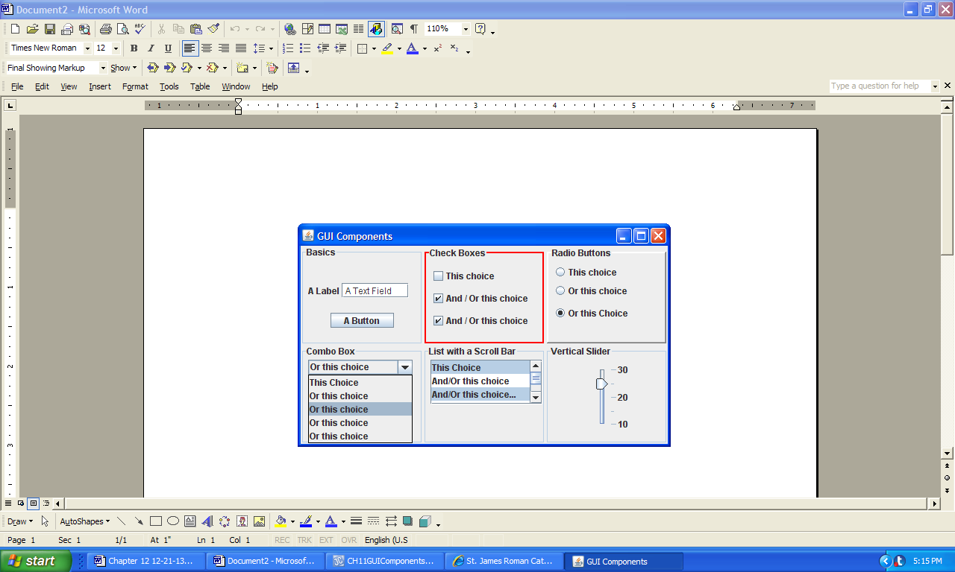

**Figure 12.1 GUI Components.**